

DEPARTMENT OF ADSE

CSE434P-Computer Networks
PROJECT REPORT

B. Tech - Computer Science and Engineering
(AIML)

Submitted By:
Abel Alexander - 2462004
Annmarie Vinish – 2462041
Darain Brit A – 2462060
4BTCSAIML A

Abstract
In disaster scenarios such as earthquakes, floods, and large-scale infrastructure failures, traditional communication networks often collapse due to damage to cellular towers and wired infrastructure. This project presents a Simulation of an Emergency Communication Network using Drone Nodes, implemented in Cisco Packet Tracer.
The system models drones as mobile routing nodes forming a self-healing network. Using OSPF (Open Shortest Path First) dynamic routing protocol, the network automatically reroutes traffic if a node fails. Additionally, Quality of Service (QoS) mechanisms are implemented to prioritize critical emergency messages such as medical alerts over regular traffic.
The simulation demonstrates how cloud and networking concepts such as redundancy, dynamic routing, traffic prioritization, and fault tolerance can be applied to disaster communication systems. This project connects theoretical networking principles with practical disaster-resilient communication design.

Background and Motivation
During disasters, communication infrastructure is often severely damaged. Rescue operations depend heavily on real-time information flow between victims and emergency response teams. Traditional networks rely on fixed infrastructure, which becomes unreliable during emergencies.
Drone-based communication systems offer a flexible alternative. By deploying drones equipped with networking devices, temporary wireless mesh networks can be created to restore connectivity.
This project simulates such a system using Cisco Packet Tracer, demonstrating how dynamic routing and traffic prioritization ensure reliable emergency communication.
Problem Statement
In disaster scenarios:
- Communication infrastructure may fail.
- Critical emergency messages must be delivered reliably.
- Network nodes may fail unpredictably.
- Traffic must be prioritized based on urgency.
The project addresses the following:
- How to simulate a drone-based emergency network.
- How to ensure communication continues even if a node fails.
- How to prioritize life-critical traffic.
- How to demonstrate dynamic routing and redundancy.
Objectives
- Simulate drone nodes using routers in Cisco Packet Tracer.
- Implement dynamic routing using OSPF.
- Create backup links for redundancy.
- Implement QoS for priority-based transmission.
- Demonstrate self-healing network behavior.
- Simulate disaster scenarios by shutting down nodes.

Methodology
- Network Design
Drone nodes are represented by routers interconnected in a mesh topology with backup links.
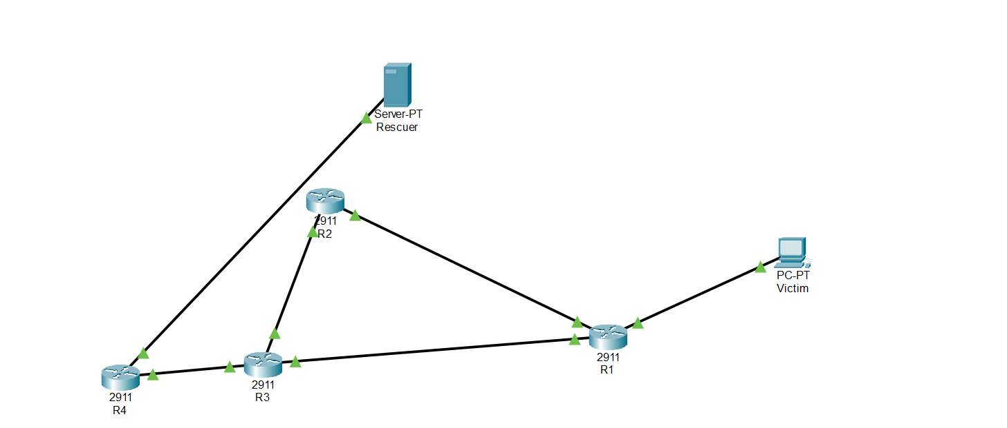
- IP Addressing
Each link is assigned a unique subnet.
- Dynamic Routing
OSPF is configured on all routers to enable automatic path recalculation.

- Redundancy
Additional links are added to create alternate paths.

- Priority Transmission
QoS policies are configured to prioritize medical traffic.

- Testing
Router failure is simulated to verify rerouting.
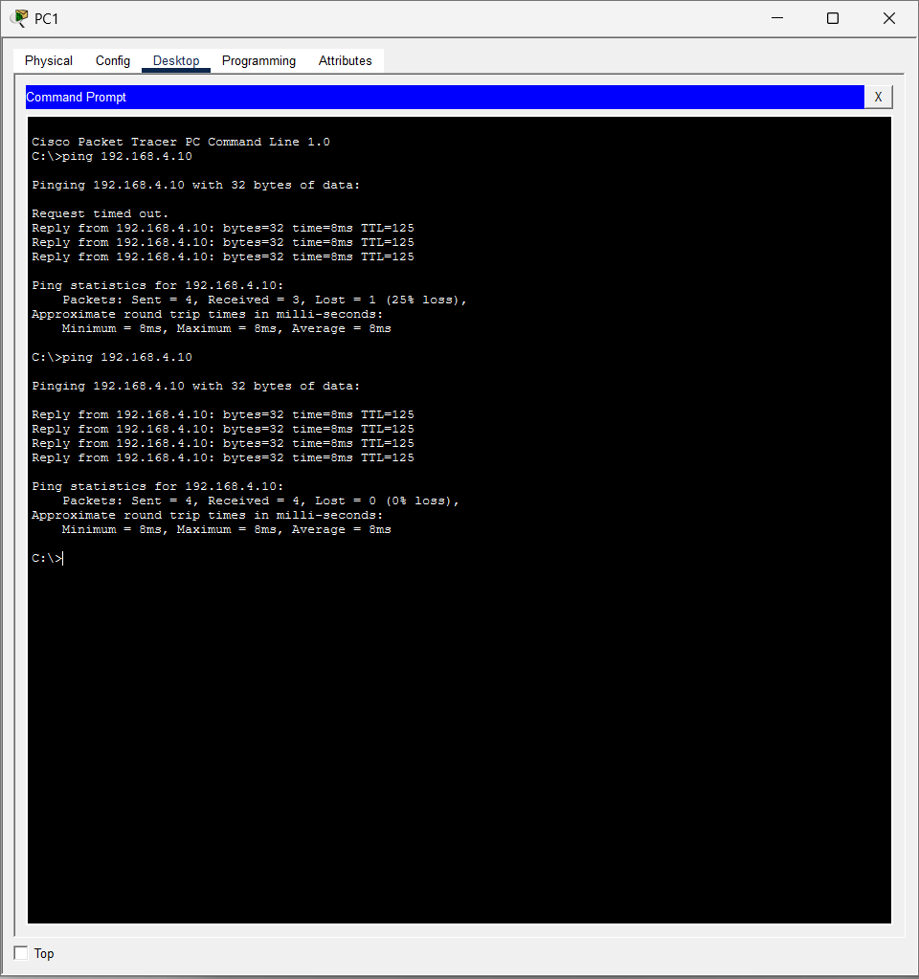
Network Topology Design
The network consists of:
- 4 Routers (Drone Nodes)
- 1 PC (Victim Device)
- 1 Server (Rescue Control Station)
Topology:
PC → R1 → R2 → R3 → R4 → Server
Backup Link: R1 ↔ R3
This structure enables alternate path routing.
Dynamic Routing Using OSPF
The OSPF protocol is implemented to allow:
- Automatic route discovery
- Shortest path selection
- Failure detection
- Automatic rerouting
When a router (drone node) fails, OSPF recalculates routes and selects the alternate path through the backup link.
This demonstrates self-healing network capability.
Quality of Service (QoS) Implementation
To simulate emergency priority:
- Port 5000 → High Priority (Medical Emergency)
- Port 6000 → Medium Priority (Food/Water Request)
- Default Traffic → Low Priority
QoS policy ensures:
- High-priority packets are transmitted first.
- Critical emergency traffic experiences minimal delay.
Disaster Simulation
To simulate a disaster:
- Router R2 is turned off.
- OSPF recalculates paths.
- Traffic reroutes via R1 → R3 → R4.
- Communication continues uninterrupted.
This demonstrates network resilience.
Results
- Successful implementation of drone mesh network simulation.
- Dynamic routing automatically rerouted traffic during node failure.
- QoS successfully prioritized emergency traffic.
- The system demonstrated fault tolerance and redundancy.
- Communication remained active even after simulated disaster.
Simulation testing confirmed:
- Normal communication flow between PC and Server.
- Successful rerouting after failure.
- High-priority packets processed before medium and low priority traffic.
Conclusion
The project successfully demonstrates how drone-based emergency communication systems can be modeled using networking principles.
By implementing OSPF dynamic routing and QoS priority scheduling, the system ensures:
- Reliable communication
- Self-healing behavior
- Traffic prioritization
- Disaster resilience
The simulation connects networking theory with practical emergency communication systems.
Future Scope
- Implement real wireless mesh simulation.
- Integrate IoT-based sensors for automated distress signals.
- Deploy using real routers or GNS3.
- Add cloud-based monitoring dashboard.
- Integrate AI-based route optimization.
- Use SDN (Software Defined Networking) for advanced control.
- Simulate UAV mobility patterns.

